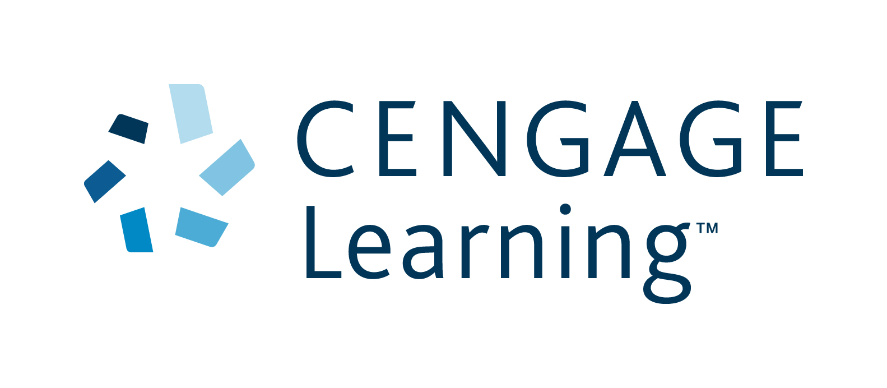

POSITION DESCRIPTION

Name: TBC

Job title: Project and Custom Manager (12 month Maternity Leave contract)

Date: April 2015

Department: Sales, Higher Education

Reports to: National Enterprise Solutions Manager

Basic purpose:

As directed by the National Enterprise Solutions Manager, the Project and Custom Manager is responsible for the management and delivery of new VPG and HE technology, service and custom projects.

Principal accountabilities:

Key Outcome and Area | % of Total Job | Objectives and Tasks | Core Competencies | Standards
Development of new, custom and special projects for the Higher Education market | 40% | - Provide specifications concerning coverage, content, approach and extent to Production Controller Custom (School and HE).  - Work with the Production Controller Custom (School and HE) on preparing costings on individual custom projects ensuring profit targets met and tracking custom workflows.  - Build and maintain effective working relationships with key academic contacts to ensure that Cengage Learning is kept up-to-date with market trends and competitor activity.  - Maintain a strong, visible and informal network of educational contacts across the university sectors, calling on campus, attending industry conferences etc.  - Ensure technology based product is incorporated in publishing in a cohesive manner, with adequate lead time.  - Ensure publishing projects are delivered on time and to budget.  - Carry out thorough market research for the project, including university visits, focus groups and surveys.  - Keep in touch with the market through a variety of channels.  - Working closely with the National Enterprise Solutions Manager on creating and delivering content to Institutions through various modes. This may include traditional print as well as other technologies and platforms.  - Work with the US custom team and local production team to ensure customer deadlines are met.  - Ensure timely delivery and quality of author generated manuscript Custom titles.  - Review project content progressively during development to ensure they meet with customer needs in terms of coverage, quality and approach.  - Ensure that each project conforms to the original proposal upon which it was signed and that it meets planned content delivery dates.  - Liaise closely with production and editorial with respect to content quality and style, schedules, book design and profitability.  - Liaise with editorial and production in regard to content presentation and style, publishing schedules, design and manufacturing requirements.  - Attend meetings to provide information and address any publishing problems that emerge during the editorial and production phases.  - Track royalty information on custom projects through finance.  - Prepare documentation for author contracts and letters of agreements.  - Liaise with Operations Manager to determine accurate payment procedures.  - Any other duties as directed. | - Ability to problem-solve and manage complex and/or numerous projects to an agreed timeline  - An excellent understanding of university developments and current teaching practice to assist customers  - An excellent knowledge of Higher Education markets throughout Australia and New Zealand  - Substantial experience in list management and ability to transfer understanding to others.  - Market awareness, including competition, product developments (including trends in use of digital material)  - Resourceful in getting things done and eliciting effort from others  - Good judgement and timely decision-making to prioritise work and effort  - Strategic and innovative thinker  - Ability to network, put others at ease and build rapport  - Effectively gather, sift and present information from a variety of sources and based on a sound understanding of publishing processes  - Excellent written and spoken communication skills  - Facility with Outlook, MS Word, MS Excel and PowerPoint  - Excellent time management skills and attention to detail  - Ability to build rapport  - Negotiation and interpersonal skills with the ability to build relationships  - Numeracy skills, financial acumen and acute commercial awareness  - Excellent communication, listening and presentation skills  - An understanding of permissions and copyright requirements  - Working knowledge of copyright law and industry best practices of text/photo/images, including contract negotiations  - Ability to follow policies and procedures  - Problem-solving abilities with keen attention to detail and follow through | - Quality of publishing proposals, plans and projects  - Accurate costings  - Meeting financial targets  - Customer-first focus  - Success of projects and adoptions  - Number of signed authors by team  - Actively establish industry relationships and utilises networks to improve knowledge which adds value  - Technology effectively incorporated into project  - Professional approach to delivering content to the standard and on time  - Project delivered on time, on budget, and within scope in accordance with business priorities  - Controlled project costs  - Market research conducted  - Friendly, proactive communication  - A positive attitude to problem-solving  - Going the extra mile to achieve the best possible outcome  - Sharing ideas and learning in a team environment  - Minimal communication problems due to effective communication  - Effective working relationships  - Ability to collaborate and liaise across the business  - Active participation and lead in meetings and conferences  - Accurate contracts to mitigate risk  - Adherence to permissions and copyright laws  - Adherence to CL policies and procedures
Project management and development | 30% | - In consultation with the National Enterprise Solutions Manager, lead the planning and implementation of each allocated HE project once the contract has been signed  - Facilitate the definition of each project scope, goals and deliverables and project team (if required).  - Define project tasks and resource requirements.  - Plan and schedule project timelines.  - Liaise directly with GPM regarding all projects ie file conversion, content files, rights clearance, customer requests.  - Monitor and report on allocated projects to all stakeholders on a regular basis.  - Present reports defining project progress, problems and solutions.  - Conduct project evaluations and assessment of results. | - Excellent project management, organisation and team collaboration skills  - Demonstrate accountability, initiative, tact and patience  - Excellent written and verbal communication skills  - Ability to follow policies and procedures  - Ability to organise detailed and complex information so that others can deal with it effectively  - Excellent communication skills  - Understand colleagues’ roles and tailor communication to meet their needs and achieve desired outcomes  - Interpersonal skills with the ability to build relationships  - Ability to make decisions with little or ambiguous data  - Strategic and innovative thinker | - Plan, execute, and deliver all projects on time, on budget, and within scope in accordance with business priorities  - Stakeholders are satisfied that requirements meet their expectations  - Stakeholders are satisfied with the frequency and quality of communication during projects  - Manuscript quality  - Manuscripts meet set requirements and standards  - Maintenance of proposal standards  - Adherence to CL policies and procedures  - Minimal communication problems due to effective communication  - Active participation and lead in meetings  - Accurate and detailed timely reports provided and project analyses  - Effective working relationships  - Drive the accomplishment of overall goals with a focus on key front-list.
Continuous improvement | 10% | - Assess on a continuous basis all Cengage Learning products for local adaptation potential.  - Continually assess the custom process in accordance with divisional plans and procedures.  - Work with other Cengage Learning companies to look for adaptation potential and to ensure we are maximising Cengage Learning resources.  - Support Continual Improvement processes throughout the entire project including supporting Project Managers with the audit process when required.  - Seek opportunities to enhance documentation, processes and supported systems to improve processes and procedures.  - Keep abreast with the continual change in technology developments and share knowledge with manager and team.  - Actively seek opportunities to extend and enhance personal knowledge and skills in order to better support customers and colleagues. | - Strategic and innovative thinker  - Extensive understanding of the publishing process  - Analytical and problem-solving abilities with the ability to follow through project to completion  - Ability to develop and implement innovative ideas  - Effectively gather, sift and present information from a variety of sources and based on a sound understanding of publishing processes  - A willingness to support and help others | - Success of projects and adoptions  - Execute and deliver initiatives to develop and implement standards and improvement  - Planning and strategic skills  - Business acumen  - Reduction in project costs  - Continuous improvement and improved efficiency  - Self initiated training and development of knowledge  - Demonstrated initiative for issue resolution and new ideas to add value to users  - Participation and contribution of processes improvement projects  - A positive attitude to problem-solving
Liaise with and support marketing and sales colleagues to ensure a clear message to customers about projects | 10% | - Manage the custom publishing program working with sales and marketing to ensure key adoptions are serviced.  - Liaise closely with the Higher Education sales team to proactively target key Custom signing opportunities.  - Attend and contribute to key academic conferences as required.  - Call on campus with sales representatives to build on contacts, support sales efforts and gather market knowledge  - Attend and actively participate at the internal biannual sales conferences, present custom initiatives and other conference activities.  - Liaise closely with the National Enterprise Solutions Manager, sales managers, Marketing Manager and Product Manager regarding marketing initiatives, promotional campaigns, sales materials, sales estimates, sales leads and proposal leads from the field.  - Participate in regular international custom publishing conference calls.  - Actively promote current projects to the wider team to explore possible extra opportunities. | - Excellent communication and presentation skills  - Strategic thinker  - An understanding of sales and marketing, business acumen  - Ability to network, put others at ease and build rapport  - Understand colleagues’ roles and tailor the communication to meet their needs and achieve desired outcome | - Active attendance at conferences  - Presentations at conferences  - Friendly, proactive communication  - Meeting attendance and participation  - Materials and information provided to designers, marketing and editorial  - Going the extra mile to achieve the best possible outcome  - Sharing ideas and learning in a team environment  - Minimal communication problems due to effective communication  - Market knowledge  - Actively establishes industry relationships and utilizes networks to improve knowledge which adds value
Workplace Health and Safety | 10% | - Be aware of duty of care and act in a safe manner.  - Ensure all company WH&S policies and procedures are adhered to.  - Be familiar with property security, first aid and fire emergency procedures.  - Report any hazardous situations, incidents or accidents and take immediate action if applicable to reduce risk of injury.  - Participate in WH&S investigations when required. | - Ability to follow policies and procedures  - Ability to use initiative and take responsibility  - WH&S aware  - Analytical and problem-solving abilities | - Adherence to WH&S policies and procedures  - Increased WH&S awareness  - A positive attitude to WH&S  - Reduction of number of WH&S incidents

Main contacts:

Internal: National Enterprise Solutions Manager, Publishing Manager, Learning Solutions Coordinator, Vice President - HE, National Sales Manager, senior publishing editors, publishing editors, developmental editors, publishing assistants, Head of Marketing, Marketing Manager, product managers, sales managers, sales representatives, International GPP Manager, market researchers, Production Controller Custom (School and HE), Head of Production, Team Lead - Digital, Creative Manager, Lead Senior Designer – HE, Permissions Research Manager, Contracts and Copyright Coordinator

External: Authors, academic contacts, booksellers, designers and editors, US custom team, international custom team, typesetters

Education / Qualifications / Experience:

Appropriate tertiary qualification
Proven successful experience in a commercial educational publishing (commissioning) role
Sound knowledge and / or experience in sales and marketing
Drivers Licence

Cengage Core Competencies:

- Speed: Proactively gets things done quickly, with a high quality of work. Overcomes barriers and continually finds ways to be more efficient.
- Focus: Identifies core business problems and opportunities; seeks and proposes solutions while avoiding distractions. Persists through achieving deliverables.
- Collaboration: Committed to helping others be successful; partners with key organisational stakeholders, individuals and teams outside own functional area to promote business alignment.

