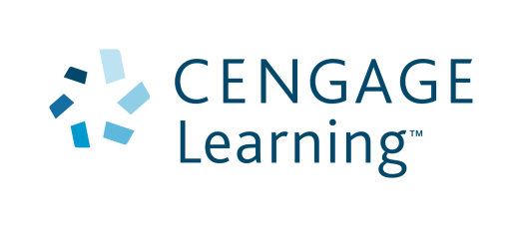

Cengage Learning Australia Pty Limited
Level 7, 80 Dorcas Street
South Melbourne VIC 3205 Australia
Tel: 61-3-9685-4111 Fax: 61-3-9685-4199
ABN 14 058 280 149 ACN 058 280 149

9 June 2015

Dear Bookseller
Effective 1 October 2013: Conditional Exemption

Cengage Learning USA has imposed global pricing on certain US published Higher Education textbooks. In Australia / New Zealand we have been able to secure exemptions on these global pricing requirements, under certain conditions. This means we are able to offer lower RRP than other Cengage companies worldwide, but to receive normal discounts on these titles, bookshops must meet certain conditions.
- Booksellers / orders qualifying under the Conditional Exemption program will be able to purchase these titles at your usual discount

- Booksellers / orders not qualifying for Conditional Exemption will receive 0% discount against RRP on orders
We hope you will be able to apply for Conditional Exemption. These are the criteria:
Category A: Campus stores
- Your business operates as a physical store
- Your business is located on a campus of a university, TAFE or tertiary institution OR is the recommended supplier for the institution / departments of that institution
- There is an adoption on the campus and your order is appropriate for the adoption student numbers
- With each sale in the physical store, your staff check student ID or membership program ID
- You on-sell the book by individual purchases in single copies only
Note: Each order must meet each criteria. For example, an order that meets the criteria might be: your business includes a physical campus store. That campus has an adoption for Weiten’s Psychology for 100 students. The campus store orders 70 copies of the book against the campus account number. The books are sold as single copies, to individuals who can show student ID for that campus. In addition, you can sell the book on your website, for single copy purchases and delivery in Australia only (for Australian stores) or New Zealand only (for New Zealand stores). Transferring stock between physical stores may breach the Conditional Exemption conditions and will require approval from a Cengage Learning sales manager.

Category B: Institutional sales
Orders from bookshops for bulk sales direct to an institution, where the institution provides the product to students under their course fees; or orders from the institution to Cengage. Usually this will be an Registered Training Oragnisation, Private Education Provider, MBA school or corporate / government sale. Product is not available for sale across the till / online to individuals. We may require disclosure of end customer details with the order or on request.
Category C: Library sales
Supplies to libraries. We may require disclosure of end customer details with the order or on request.
Category D: One off orders
One off orders for a student enrolled at an institution of study in Australia, New Zealand or Pacific Islands, when your bookshop does not meet Conditional Exemption in Categories A, B, C. We will need email confirmation of student name, ID number and institution emailed to anz.customerservice@cengage.com at time of order.
What you should do now:
- If the majority of your orders will meet the requirements apply for entry to the Conditional Exemption programme by emailing anz.customerservice@cengage.com
- We reserve the right to not supply orders under the Conditional Exemption programme if we judge the conditions are not being met
- If you receive an invoice with 0% discount and believe you qualify for Conditional Exemption on that order, please contact Customer Service
Thank for your patience as we work through this process. If you have any questions please feel free to contact us.
Thanks and regards
Cengage Learning
Tel 1300 790 853 (AU) / 0800 449 725 (NZ)
Email anz.customerservice@cengage.com

